Manual Test Plan

(The screen is not adaptive currently)

Run GUI - Start menu, 4 buttons listed together in the middle of frame. A caption for the game and a title for the window.

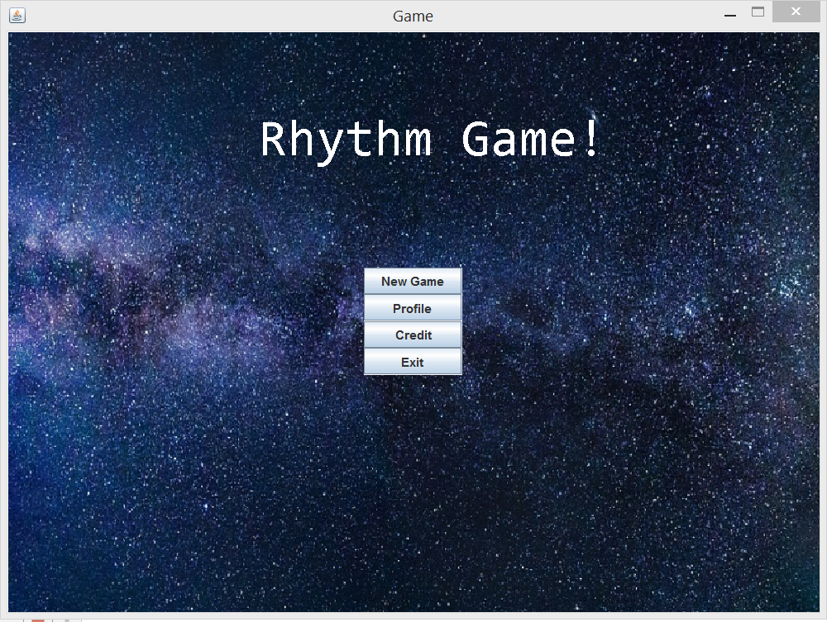

Press Profile. Top left is an avatar image, bottom left is a list of highest scores for songs player have played. The right side is an achievement board. The default avatar is a smiling face. Press upload avatar, Players can upload their avatar by selecting images in their local drives.

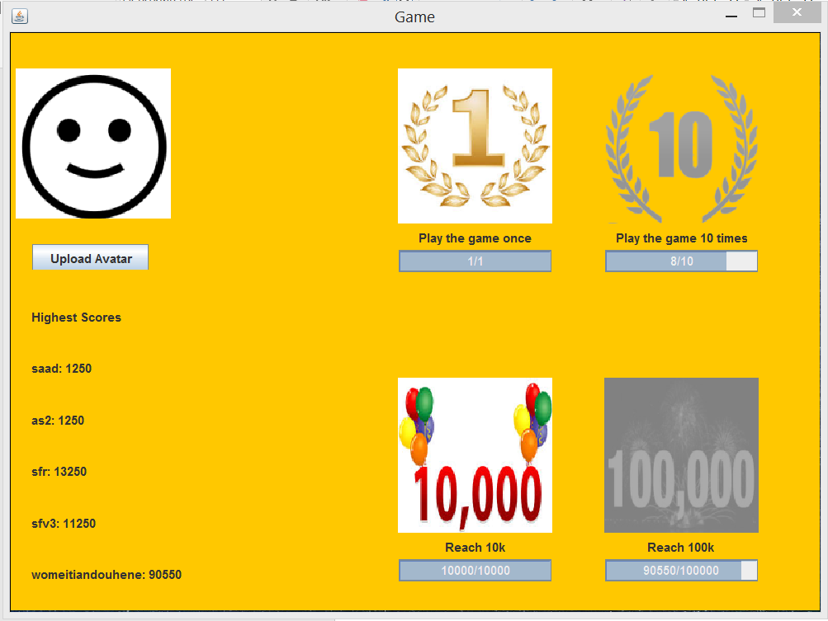

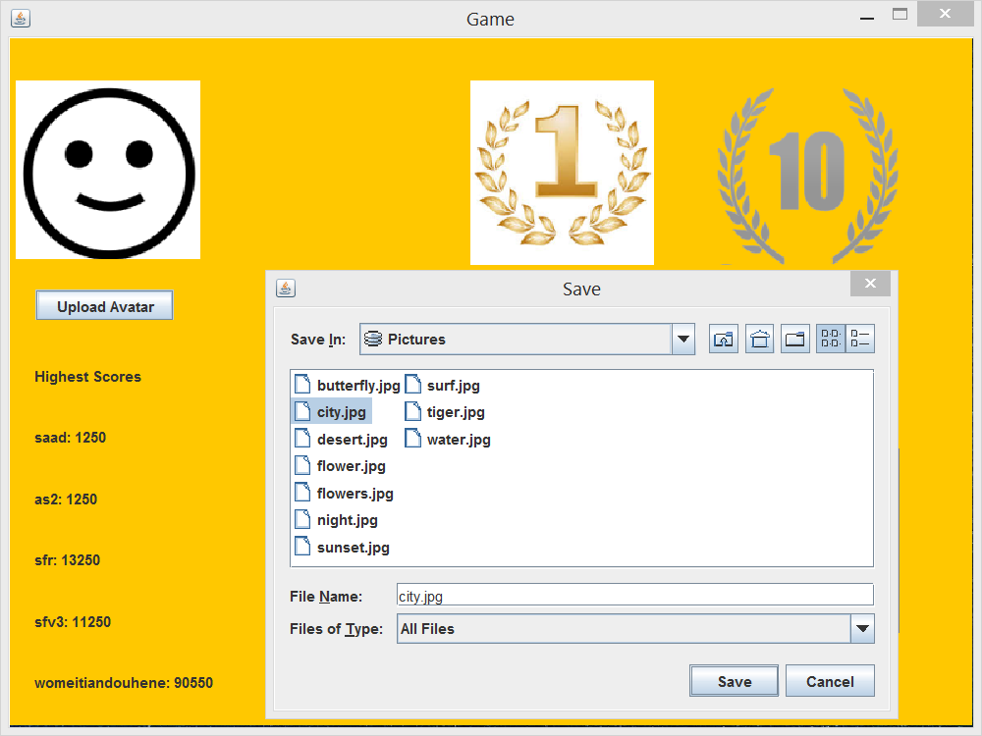

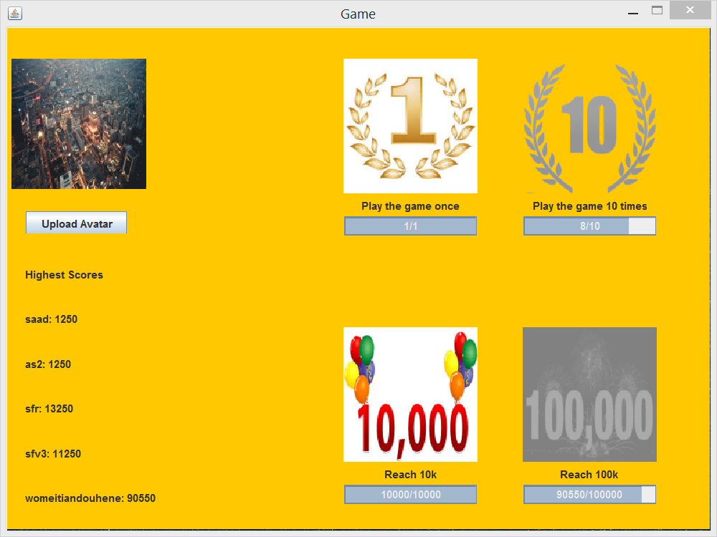

Manually entered scores for some songs and plays for achievements board testing.

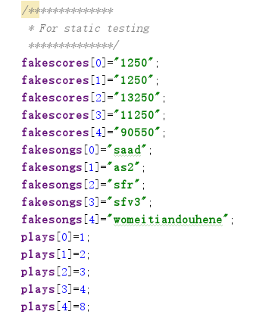

The highest score in this case is 90550 and maximal plays is 8. So “Play the game once” and ”Reach 10k” will be unlocked and the icons accordingly will be colored.

Screen Switching (no back button at present)



Press New Game – 2 buttons with song names and 2 preview images for the songs.

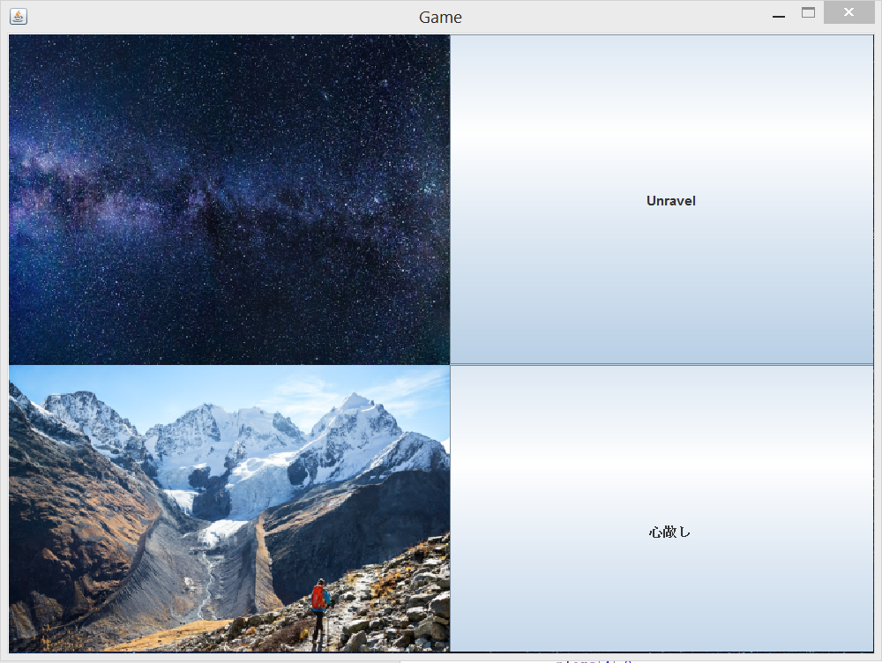

Press Unravel – difficulty level selection screen, 3 levels – east, normal and expert.

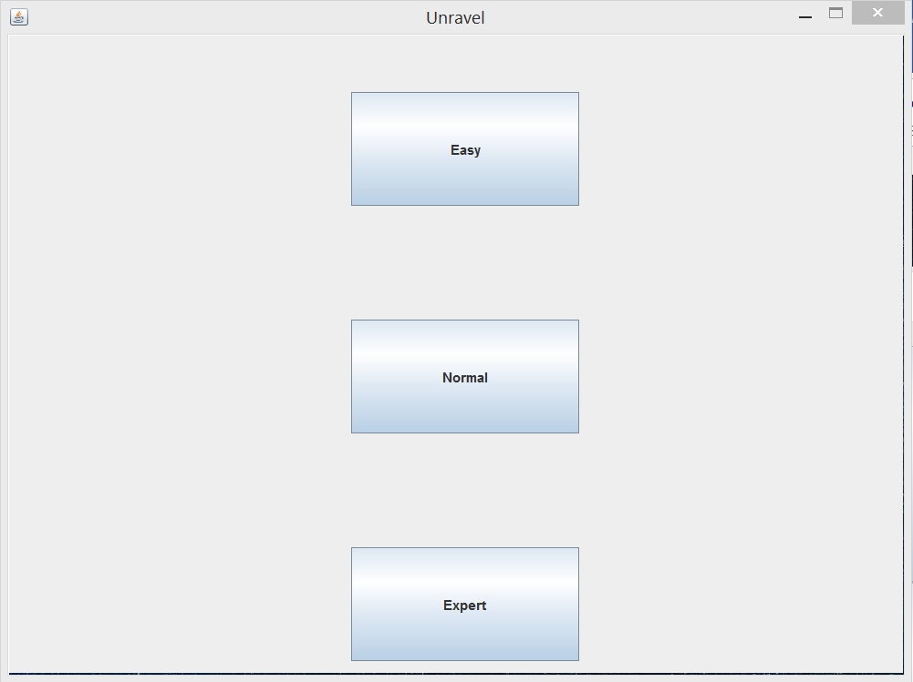

Press Easy – start game. (the frame’s title has changed to Game on) – no Game screen implemented.

